LATIN AMERICAN STUDIES 201
Fall 2007

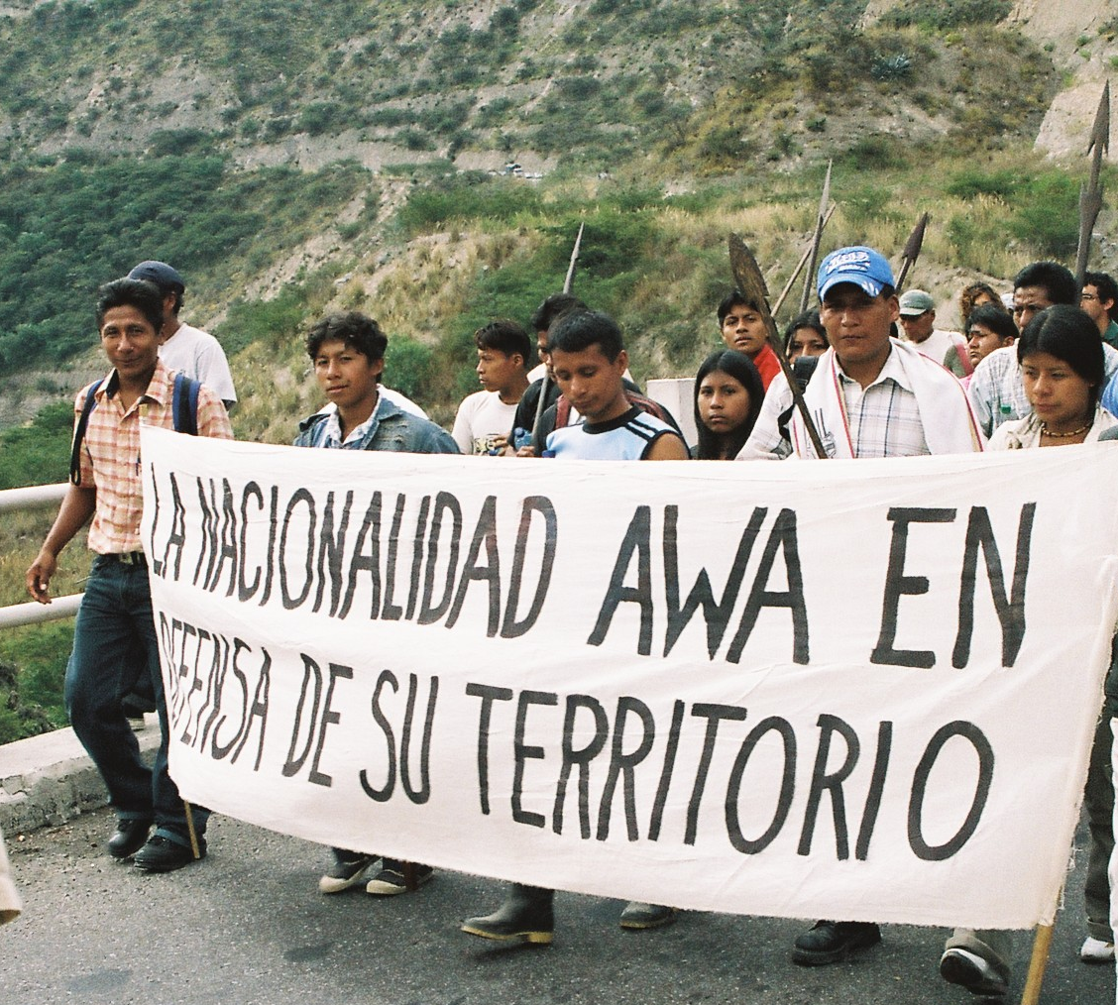

TUESDAYS AND THURSDAYS 11:00 AM-12:15 PM
WHITEHALL CLASSROOM BUILDING 303

Instructor: Juli Hazlewood
PhD Student in Geography

Office Hours: TUESDAYS 9-10:30 and WEDNESDAYS 11-12:30 or by appointment

Office: 1339 Patterson Office Tower
Phone: 859-257-9639
Email: jahaze@gmail.com

COURSE GOAL AND OBJECTIVES OF THE COURSE

THE GOAL OF THIS COURSE IS TO BEGIN TO UNRAVEL NORTH-SOUTH RELATIONS BY USING TWO METHODS: One is that you begin to excavate or dig into the colonial foundations of “the discovery” and the continuation of the idea of “the South” or “Latin America. And two is that you begin to inquire why “the decolonization project” is important to those resisting the socio-political, cultural, and economic geographies of “the North”.

There are FOUR PRIMARY OBJECTIVES of this course that will hopefully help us to meet our goal to better understand North-South relations:

1. We will explore the political economies and political ecologies of the particular countries and regions of Latin America through reading about and discussing current events and political, economic, socio-cultural, and ecological processes.
2. We will specifically focus on decolonizing the concept of Latin America through focusing upon colonial processes of boundary-making and de-colonizing strategies of boundary-breaking.
3. We will decolonize knowledge and the classroom by using such pedagogies as facilitation and Paulo Freire’s “problem-posing education” to “liberate” ourselves from “deposit-making” or “the banking model” of education.
4. To improve our abilities to clearly express ourselves and our ideas by becoming better critical writers and to become more familiar with “the culture of academia”.

GLOSSARY OF KEY INTELLECTUAL APPROACHES IN THIS COURSE
These are definitions that I found, but within the course I would like us to come to new and more complete understandings of these terms.

Political Economy-A theoretical tradition that emphasizes the belief that political and economic systems and processes are inextricably linked (Barnes 2000: 594).

Barnes, Trevor. 2000. “Political Economy”. Pp. 593-595 in The Dictionary of Human Geography, Fourth Edition, edited by R.J. Johnston, Derek Gregory, Geraldine Pratt, and Michael Watts. Malden, MA: Blackwell Publishing.

Political Ecology-“An approach to, but far from a coherent theory of, the complex metabolism, between NATURE and SOCIETY [and goes] back to an early history of relations between Anthropology and Geography in the 1940’s and 1950’s (Watts 2000: 590). In the last 15 years it has met up with the proliferations of environmental study emerging from history, science studies, POST-STRUCTURALISM, and NEW SOCIAL MOVEMENTS” (Watts 2000: 592; emphasis in text).

Watts, Michael. 2000. “Political Ecology”. Pp. 590-593 in The Dictionary of Human Geography, Fourth Edition, edited by R.J. Johnston, Derek Gregory, Geraldine Pratt, and Michael Watts. Malden, MA: Blackwell Publishing.

Post-colonialism-“A critical politico-intellectual formation that is centrally concerned with the impact of COLONIALISM [as a specific type of structure, and therefore a formation of post-stucturalism] and its contestation on the cultures of both colonizing and colonized peoples in the past, and the reproduction and transformation of colonial relations, REPRESENTATIONS [such as in post-colonial scholar’s discourse analysis], and practices in the present” (Gregory 2000: 612; emphasis in text).

Gregory, Derek. 2000. “Post-Colonialism”. Pp. 612-625 in The Dictionary of Human Geography, Fourth Edition, edited by R.J. Johnston, Derek Gregory, Geraldine Pratt, and Michael Watts. Malden, MA: Blackwell Publishing.

Decolonization- In Decolonizing Methodologies: Research and Indigenous Peoples by Linda Tuhiwai Smith (1999), she describes decolonization as engagement with colonialism and imperialism at multiple levels, and going beyond post-colonial discourse analysis to the more revolutionary, anti-colonial work of activists—like Frantz Fanon— who draw upon black and African American writers who are concerned with human and civil rights. She proposes that decolonization is a two part process in a political, social, spiritual and psychological search for the “authentic” self. One, decolonization involves reaching back to colonized time to recover from the fragmentation and articulate what it means to be dehumanized by colonization. And two, decolonization requires reaching even further back to pre-colonized time to reorganize indigenous national consciousness, “to recenter indigenous [and immigrant and diasporic] identities on a larger scale” (1999: 97; emphasis added). In short, the goals of the decolonization project involve “…the survival of peoples, cultures, and languages; the struggle to become self-determining, the need to take back control of our destinies” (Tuhiwai Smith 1999: 142).

Tuhiwai Smith, Linda. 1999. Decolonizing Methodologies: Research and Indigenous Peoples. London and New York: Zed Books, Ltd. and Dunedin, New Zealand: University of Otago Press.

REQUIRED TEXTS

- Green, Duncan. 2006. Faces of Latin America (third edition). United Kingdom: Latin America Bureau.
- Mignolo, Walter D. 2005. The Idea of Latin America. Malden, MA: Blackwell Publishing.
- Goodwin, Paul B. 2007. Global Studies: Latin America. Dubuque, IA: McGraw-Hill/Contemporary Learning Series.

GRADING AND EVALUATION

**ALL ASSIGNMENTS ARE TO BE DOUBLE SPACED, 12 POINT FONT, TIMES NEW ROMAN, AND TO BE STAPLED**

Course Grading Rubric
Participation & Attendance: 20% to be evaluated during semester
Map Quiz: 10%, September 20th
Facilitation and facilitation review/project: 5% do once during semester.
Exams: 30% Midterm due October 11th; Final exam December 13th, 10:30 am.
Review Paper: 15%, due October 30th.
Final Paper: 15% due November 27th or 29th
Presentation of Final Paper: 5% due November 27th or 29th
TOTAL: 100%
Participation and Attendance: 20%
Attendance is critical. If you are not there, you cannot participate and/or contribute to the discussion group. This is a class collaborative experience, thus it is critical that every individual arrives on time, does the readings, and contributes. If you cannot attend discussion section, you must email me or call at least 2 hours before class. If you did not attend a section, you are responsible for all material you might have missed. You are permitted to have one excused absence.

Attendance will be taken by a question about the reading (be as creative and open-ended as you like with these!) that you bring to class and give to me as you walk into class. You will be responsible for asking your question during discussion if you choose to do so. Therefore, you may need to bring 2 copies- one for me and one for yourselves. Each absence beyond your excused absence is .66 less on the final participation grade (worth 20 points/ 30 classes= .66 each class), unless there is a valid excuse. If you do not turn in a question, you are counted as absent.
In this course, participation is defined as quality contribution to class discussions. Attending class alone will NOT lead to high participation grade. Students must attend class, turn in questions, and participate in discussion. Comments should be thoughtful, engage with readings, films, lecture, guest speakers, and other students. Students should demonstrate that s/he is working through the material and making connections between concepts and topics.

Map Quiz: 10%: SEPTEMBER 20th

This is rather self-explanatory. You will be expected to fill in a blank map of the current boundaries of Central and South America and Caribbean Nations. You will be asked to name selected physical features-oceans, rivers, and mountains, and regions, nations, and cities and capitals on a map. (You will be given a list and practice maps.)
Co-facilitation and co-facilitation project: 5% or 10%: do once during semester (5% if choose to do final presentation or 10% if you choose not to do the latter)

As co-facilitators, your assignment is to ensure a productive class period and discussion. You have two options: One, you can co-facilitate a discussion about all readings. Or two, each co-facilitator will choose one of the readings (chapter, article) and start/lead discussion on the assigned day. BUT you must do your facilitation project together and facilitation reflection sheets individually. See “Responsibilities of Facilitating” handout for exact details. You MUST follow the guidelines on that handout as well as those outlined below, as facilitation is a skill I would like to share with you.
A. Facilitation Reading review: Prepare a one page document with the reading’s main ideas, concepts, terminology, people, events, and arguments. Then on a second page, write five main questions that you would want to bring to the class. You can be as creative as you like with these discussion questions.

OR….
B. Facilitation Project: You can write a reflection, a poem, do a drawing (no stick figure quality sketches please), do a collage, or anything else you come up with (to be discussed in our pre-facilitation meeting. It must be equivalent of the work it would take to do option A, the facilitation reading review. You could also do an “extra credit activity” (read a newspaper article, attend an event, or read a recommended reading) and tie your activity and response (SEE “EXTRA CREDIT” SECTION ON PAGE 8 for a thorough description) into the readings you were assigned to facilitate.
I will not accept any late facilitation reading reviews or facilitation projects. This assignment should prepare you to lead a discussion and help the students to process the ideas that we have read about for that day, and, therefore, cannot be made up. DO NOT FORGET ABOUT THE MEETING WITH ME AT LEAST 2 DAYS BEFORE CLASS AND TO TURN IN YOUR FACILITATION REFLECTION SHEET THE FOLLOWING CLASS AFTER THE ONE FOR WHICH YOU FACILITATED.

Review Paper: 15%: Due October 30th.
Analytical writing is essential to your career as a college student, and will greatly aid you in most post-graduate occupations. This assignment asks you write a critical essay on Walter Mignolo’s The Idea of Latin America in relation to a historical or current topic in a Central American country that we have read about. If you would like to discuss a current or historical event that we have not read about, please check with me. I will pass out a handout that includes the exact question and directions on October 18th and the paper will be due on October 30th. Please refer to the review guides on how to structure your essay, but you will need to have a clear introduction, thesis statement, a body of the essay that presents proof to back up your thesis statement, and a conclusion. Essays should be approximately 1000 words long. Review papers WILL NOT BE ACCEPTED LATE, but will gladly be accepted early.
Each paper should be formatted according to the following:
1. Use Times New Roman 12 point font, double spaced.
2. You may print double-sided.
3. Any reference sources MUST be cited under “works cited” at the end of the paper.
4. Use APA citation format. www.apa.org
5. Staple your paper. I will not accept un-stapled papers.
Exams: 30% (2): MIDTERM TO BE HANDED OUT OCTOBER 4th and DUE OCTOBER 11th; Final Exam December 13th at 10:30 am
The midterm exam will be a take home essay of no more than 1000 words and no less than 750 words which responds to a question that I send home with you. The question will have to do with what we have read up to that point in class. The purpose of the take home exam is also to evaluate your writing. So, like your review paper, you will need to have a clear introduction, thesis statement, a body of the essay that presents proof to back up your thesis statement, and a conclusion. You will all need to meet with me in office hours to discuss your essay in order for me to return it to you.

The final exam will be a combination of definitions, multiple choice, true/false, and short answer. Any and all required material, including class discussions may appear on the exams.
Final Paper: 15%, due November 27th or 29th.
Using the Green book, choose any topic of interest (one of his sections in his chapters). Examples are: Land and Conflicts, Gender and Politics, the State and the Military, Social Movements and Change, Race and Ethnicity. I will then assign you a country (you can put in requests). Your assignment will be to use the Green and Goodwin books and 3 additional sources (see below) to discuss the topic you chose within the context of your assigned country in 750-1000 words. If you would like to research a particular country, please let me know by mid to late October or as soon as possible.

This assignment requires you to find at least 3 SOURCES:
1. A periodical articles, from legitimate sources.
2. An academic articles or book.
3. A miscellaneous item: this may be either of the above, or include songs, films, photos, websites, art exhibits, interviews, radio shows or other media.

Presentation of Final Paper: 5% (if choose to do this, making facilitation worth 5%, if not 10%) due November 27th or 29th

This assignment gives you 2-4 minutes maximum to present your project. 10% of your grade will be based on if you attend the day that you are not presenting. You can use power point (no more than 5 slides!), but it is not required. Your grade will be based on your sharing of 6 main points: Your name, Title of presentation, why you chose the topic, what was your thesis statement, 3 main lines of evidence/support for your thesis, and 2 conclusions (each of these worth 10% of your grade).

Extra Credit
The purpose of the extra credit assignment is to bring more information and commentary into the classroom. You may complete 3 extra credit assignments throughout the semester. These are due IN CLASS.

1. TO COMPLETE THIS ASSIGNMENT YOU MUST FIRST DO THE FOLLOWING:
A. Find a newspaper article related to course material
OR
B. Attend a relevant UK event: speaker, film, art showing, or anything else in the Lexington area (including campus). In cases where I require attendance, you may write up the assignment and present it to the class to get extra credit.
OR
C. Review one of the extra credit readings. Ask me for any of the recommended readings at least one class period ahead of time.
2. THEN WRITE A 2 PAGE RESPONSE TO EITHER THE ARTICLE OR EVENT.

Your response should include both a summary and critique of the topics covered and at least 1 paragraph in which you relate the article or event to course materials.
3. LASTLY, YOU MUST PRESENT YOUR RESPONSE TO THE CLASS.
Responses turned in WITHOUT class presentation WILL NOT RECEIVE CREDIT. THIS MEANS THERE IS NOT EXTRA CREDIT DURING FINALS WEEK. Do not ask me for extra credit at the end of the semester. You have the opportunity to raise your grade from day 1.

READINGS AND ASSIGNMENT SHEDULE

Generally, we will not read more than 40-50 pages per week, so it is imperative you do the reading and come prepared to class.

FAC=co-facilitator will lead class that day

WEEK 1: Introductions
Thursday, August 23rd: Introduction of instructor: introduction exercise; read over syllabus; and discuss co-facilitation.

WEEK 2: Latin America and Latin American Studies
**BUY YOUR BOOKS THIS WEEK!**
Tuesday, August 28th: LAS class pedagogy: decolonization of the classroom and creating a collaborative learning experience.
Readings: Ted Rico and my documents about Facilitation (5 Ted; 2 mine--7 pages total); Freire: Pedagogy of the Oppressed, Chapter 2 (57-74--pages 2-11 with numbers on bottom)
Thursday, August 30th: More about collaborative learning and imagining pre-colonial Latin America
Kahn: The Seminar (11 pages); Mann 1491 (41-53)

WEEK 3: Constructing Latin America: the Notion of the Other
Tuesday, September 4th: What is Latin American Studies and why bother? (FAC)
Readings:
Skidmore, Thomas E. and Peter H. Smith. 2005. Why Latin America? Pp. 1-12 in Modern Latin America, Sixth Edition edited by Skidmore and Smith. Oxford: Oxford Press
Bray, Donald. 2004. New Latin American Pedagogy. Latin American Perspectives. 134: 31(1): 10-22.
Thursday, September 6th: Construction of Latin America and Other-Thinking (FAC)
Readings: Goodwin: Latin America: Myth and Reality (pp.1-4)
Green: Introduction and History and Power (pp.1-11)
Mignolo Preface: Uncoupling the Name and the Reference (X-XX)

WEEK 4: Mexico
Tuesday, September 11th: Mexico and Colonial Foundations. Go over maps. GUEST SPEAKERS: Chris Poole, Anthropology and Francie Chassen-Lopez, History
Readings: Readings: Goodwin: 7-15
Mignolo 1-15
Thursday, September 13th: The Idea of Latin America and Current Events in Mexico. Go Over Maps. (FAC). GUEST SPEAKER?
Readings: Goodwin 182-186
Mignolo 15-34

WEEK 5: Colonialism, Cultural Collisions and Colonial Wounds
Tuesday, September 18th: Occidentalism and the West (FAC). Go over maps.
Readings: Mignolo 34-50
Thursday, September 20th: MAP QUIZ
Readings: Take a break from readings and study for MAP QUIZ. If extra time in class talk more about Mignolo…

WEEK 6: Central America and Coloniality
Tuesday, September 25th: Cultural Collisions and Twisting the Past (FAC)
Readings: Mignolo 50-72
Thursday, September 27th: Central America and Reconfiguring Coloniality and Latinidad (FAC)
Readings: Mignolo 72-89
Goodwin 16-21 and 187-188

WEEK 7: Diversity in Latin America and Belize, Costa Rica and El Salvador
Tuesday, October 2nd: Many Faces of Latinidad and Belize, Costa Rica, and El Salvador (FAC)
Readings: Mignolo 89-101; Goodwin 22-33.
Thursday, October 4th: Indigeneity in Latin America and Guatemala and Honduras; GUEST SPEAKER: Sarah Lyon, Anthropology
Readings: Mignolo 115-128
Goodwin 34-42

WEEK 8: Ethnicity and Guatemala and Honduras
Tuesday, October 9th: African Diaspora in Latin America and Current Issues in Belize, Costa Rica, and El Salvador. HAND OUT MIDTERM. (FAC)
Readings: Mignolo 101-115
Goodwin 189-195.
Thursday, October 11th: “Latin” America? and Guatemala and Honduras. GUEST SPEAKER: Ana Hasemann, Anthropology (FAC) MIDTERM DUE
Readings: Mignolo 128-148
Goodwin 196-197.

WEEK 9: After “America” and Nicaragua and Panama
Tuesday, October 16th: Postscripts and Nicaragua and Panama (FAC)
Readings: Mignolo: 149-162
Goodwin 44-51; 198-199
Thursday, October 18th: Commodities in Latin America and Introduction to South America HAND OUT REVIEW PAPER
Readings: Green: The Curse of Wealth 12-27
Goodwin 52-59

WEEK 10:
Tuesday, October 23rd: Silent Revolutions and the Market (FAC)
Readings: Green: Silent Revolutions 28-48
Goodwin 179-181
Thursday, October 25th: The State and the Military (FAC)
Readings: Green: The State and the Military 51-71
Goodwin 165-178

WEEK 11: Politics
Tuesday, October 30th: The Left in Latin America (FAC) REVIEW PAPER DUE
Readings: Green: The Left in America 71-86
Thursday, November 1st: Land and Conflicts (FAC)
Readings: Green: Promised Land 89-104

WEEK 12: Immigration and Land
Tuesday, November 6th: Emigration(s); Migration(s); Immigration(s) and Brasil (FAC) and Ecuador GUEST SPEAKER: Maria Moreno, Anthropology
Readings: Green: Mean Streets 104-116
Goodwin 69-77 and 88-91
Thursday, November 8th: Brasil and Ecuador Today (FAC)
Readings: Green: Land in Flames
Goodwin: 202-204 and 207-209

WEEK 13: Race, Ethnicity and Gender
Tuesday, November 13th Race and Ethnicity and Bolivia and Argentina (FAC)
Readings: Goodwin 60-68 and 200-201
Green: Race and Ethnicity 135-148
Thursday, November 15th: Gender and Politics and Chile (FAC)
Readings: Green: Gender and Politics 148-166
Goodwin 78-82 and 210-211

WEEK 14: Social Movements and Change
Tuesday, November 20th: Social Movements and Change and Venezuela (FAC)
Readings: Green: Social Movements and Change 166-176
Goodwin: 110-115 and 215-220 (Venezuela)
Thursday: NO CLASS- HAPPY THANKSGIVING

WEEK 15: Cultural Identities, Church and Peru and Collombia
Tuesday, November 27th: Presentations for 30 minutes in class.
Readings: Green: Cultural Identities and Politics 179-200
Goodwin 98-103 (Peru) and 83-87 (Colombia) and 213-214
Thursday, November 29th: Presentations for 30 minutes in class
Readings Green: Church and Conclusion 200-217
Goodwin: 205-206

WEEK 16: Wrap up: The Caribbean
Tuesday, December 4th: Antigua and Bermuda, The Bahamas, Barbados, Cuba, Dominica, Dominican Republic
Readings: Goodwin 116-142
Thursday, December 6th: Grenada, Haiti, Jamaica, St Kitts-Nevis, St. Lucia, St.Vincent and the Grenadines, Trinidad and Tobago (FAC)
Readings: Goodwin: 142-164

Final Exam: THURSDAY DECEMBER 13TH at 10:30 AM in CB 303.

POLICIES
Classroom Ethics
As a discussion-based class, I expect everyone to be respectful of the thoughts, questions, and perspectives of others. The readings provide much new information and address controversial topics, and my hope is that everyone will gain from engaging with each other, above and beyond the reading material.

DISRESPECTFUL BEHAVIOR WILL NOT BE TOLERATED.
As a Salsero named Henry Fiol sings (in Spanish), “I have the recipe to save the world… RESPECT”.
Classroom and Learning Accommodations
Should you have any special needs, please alert me to this fact as soon as possible. UK has wonderful support resources and facilities for students with all kinds of disabilities- Any student with a disability who is taking this course and needs classroom or exam accommodations should contact the Disability Resource Center, 257-2754, room 2 Alumni Gym, jkarnes@uky.edu. In order for special arrangements to be made, please provide me with the necessary documentation and all efforts will be made to accommodate your needs.
Office Hours
Tuesdays 9 am-10:30 am and Wednesdays 11 pm – 12:30 pm AND BY APPOINTMENT.
Office hours are provided to give you an opportunity to speak with me individually about any questions, comments, concerns or ideas you have about any course material. Email has often come to replace the face-to-face time, but I encourage you to take advantage of these hours.

Email Policy
I do my best to respond to emails and discussion board posts within 48 hours. I do not respond to questions about assignments within 24 hours of their due date. Email traffic has extended office hours ad infinitum, and I ask that you respect that I have other responsibilities in addition to being an instructor. Please use your contact sheet to ask one another questions before sending me an email.
Absences and Make-ups
You must have a university-approved excuse and documentation from the Dean’s office, and this must be shown to me within one week of the absence. You are expected to notify me via email or phone before the missed class. I do not accept late work without a university-approved excuse or doctor’s note. I absolutely do not make exceptions to this policy. Please read Senate Rules 5.2.4.2, which defines “excused absences” if you have questions or doubts about what does and doesn’t count as an excused absence.
All rescheduled exams, quizzes, etc. will be proctored on the last Friday of the semester, and will consist of an essay test (except for maps). I do not do individual make-ups, including map quizzes. If you know you will be missing a class, you may schedule to take the quiz or exam early.
Assignments and Readings
All assignments are due at the beginning of class on the due date. In the event that online submission is permitted, this holds true as well.
Readings are assigned on a weekly basis, and should be completed by class each week. I expect all students to come to class ready to discuss the main themes in each of the readings. If you do not understand elements of the reading, please ask in class! Even seemingly simple questions can start great class discussions. If you are having difficulty understanding or completing the readings, see me as soon as possible.
Statement on Academic Honesty
Please know that I have no tolerance for plagiarism or cheating of any kind. Cheating and Plagiarism will result in an automatic E in the course- no exceptions. Your presence at the University of Kentucky indicates your commitment to your own education and learning. Plagiarism is detrimental to your own education and the community of learning we have at the University. If you have any questions about what or how to properly cite sources, please ask me in class or in the online discussion board so that all students can hear/read the answer. Or, when in doubt, cite it.
Please read the UK Student Code of Conduct[1] 6.3.1 “Plagiarism”, if you have any questions. You can also read UK Student Code of Conduct 6.3.2 “Cheating”, for its complete definition. If you have any question as to what you are doing is cheating, it probably is, so choose another path to completing the assignment, like doing the work yourself!

